**WEEK 1:**

**WRITEUP:**

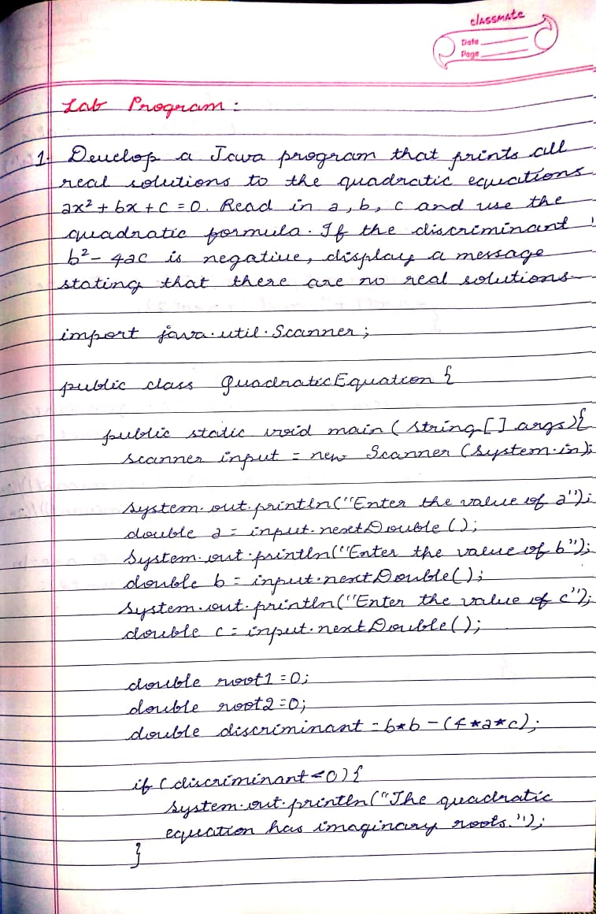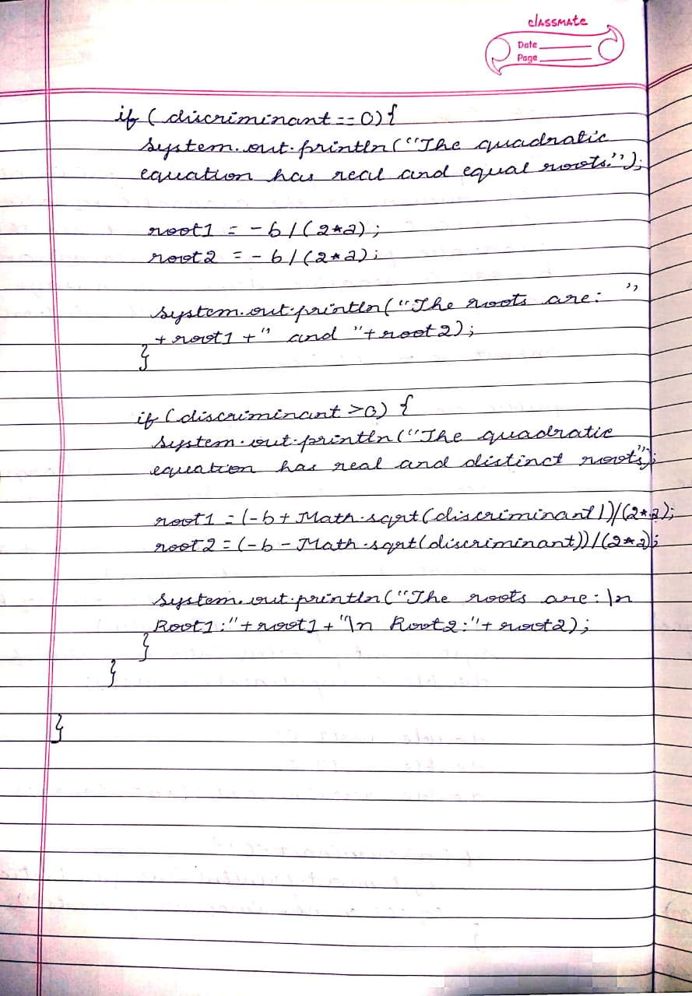

**SOURCE CODE:**

**import java.util.Scanner;**

**public class QuadraticEquation {**

**public static void main(String[] args){**

**Scanner input= new Scanner(System.in);**

**System.out.println("Enter the value of a");**

**double a=input.nextDouble();**

**System.out.println("Enter the value of b");**

**double b=input.nextDouble();**

**System.out.println("Enter the value of c");**

**double c=input.nextDouble();**

**double root1=0;**

**double root2=0;**

**double discriminant= b*b-(4*a*c);**

**if(discriminant<0){**

**System.out.println("The quadratic equation has imaginary roots.");**

**}**

**if(discriminant==0){**

**System.out.println("The quadratic equation has real and equal roots.");**

**root1=-b/(2*a);**

**root2=-b/(2*a);**

**System.out.println("The roots are: "+root1+" and "+root2);**

**}**

**if(discriminant>0){**

**System.out.println("The quadratic equation has real and distinct roots.");**

**root1=(-b+Math.sqrt(discriminant))/(2*a);**

**root2=(-b-Math.sqrt(discriminant))/(2*a);**

**System.out.println("The roots are:\n Root1:"+root1+"\n Root2:"+root2);**

**}**

**}**

**}**

**OUTPUT:**

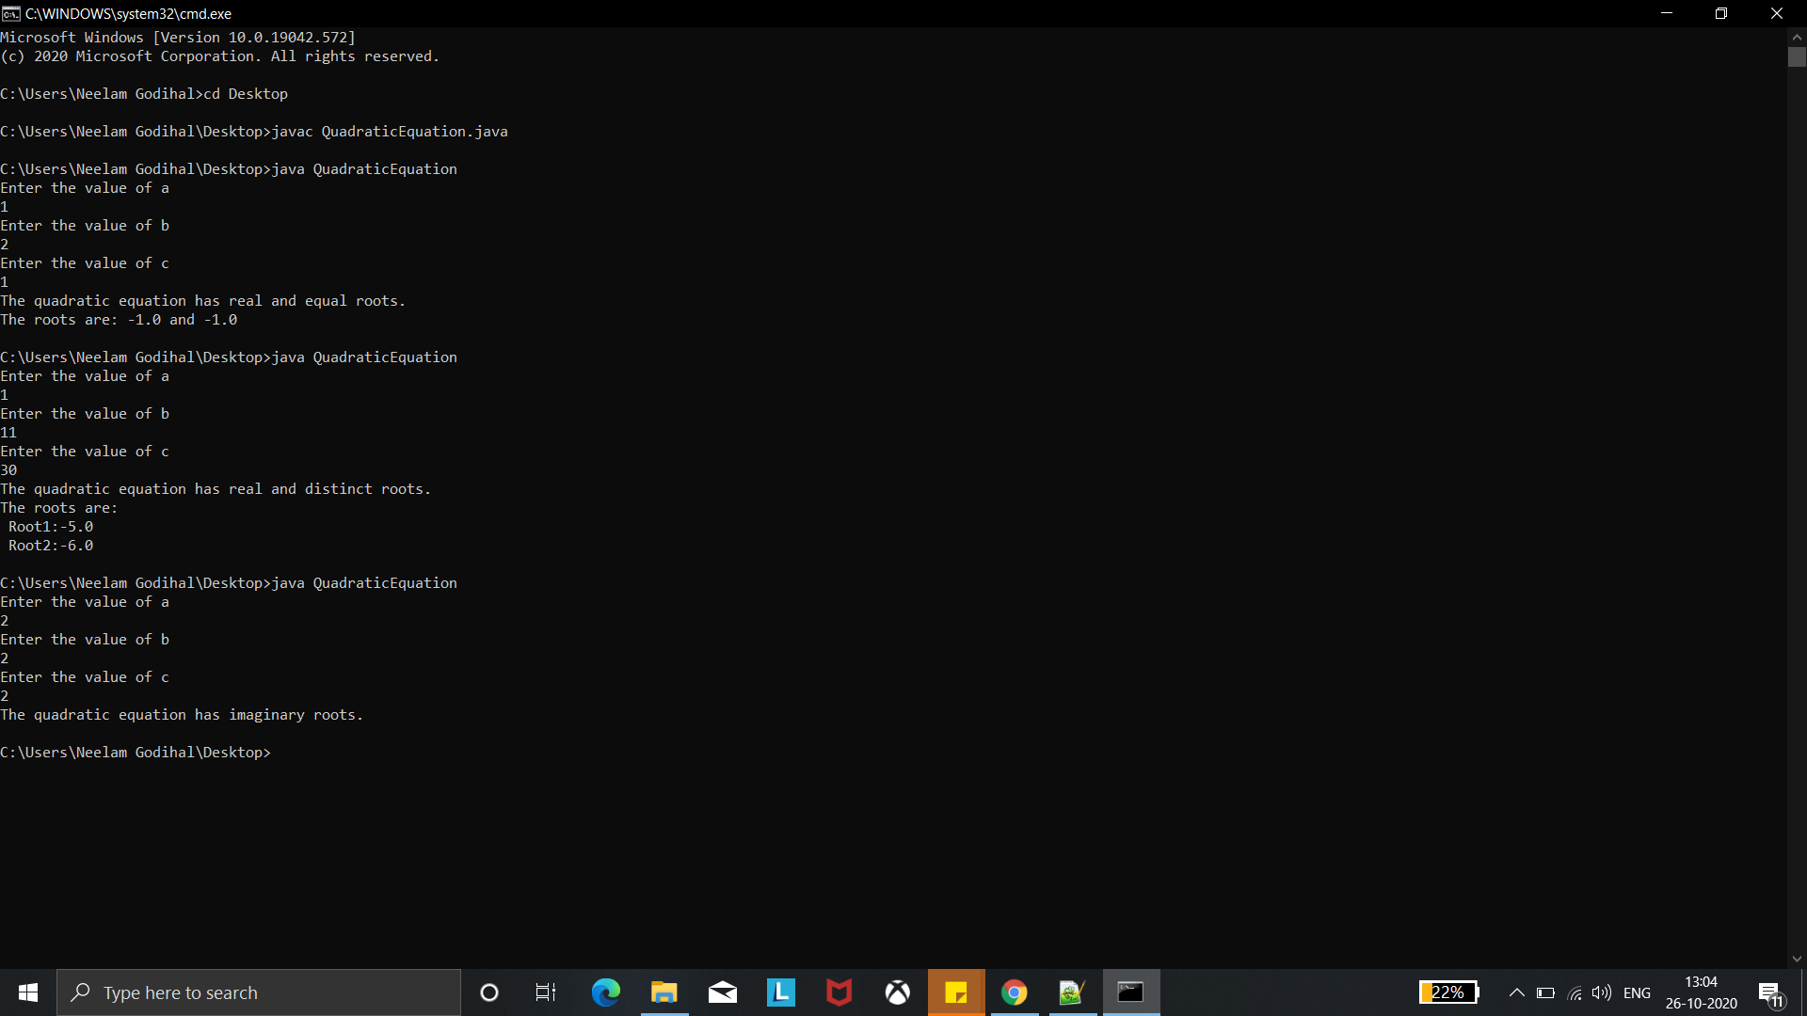

**WEEK 2:**

**WRITEUP:**

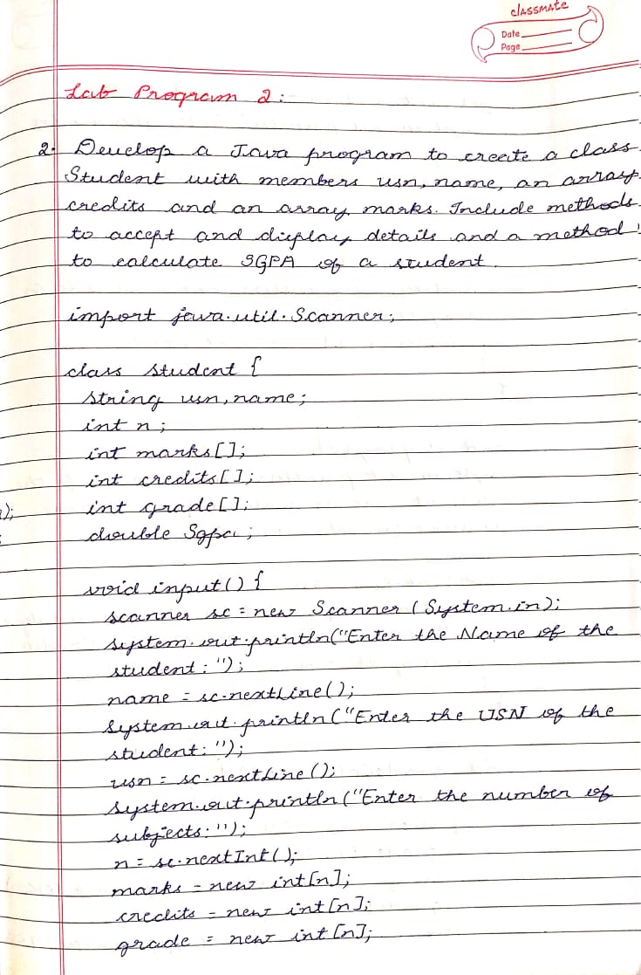

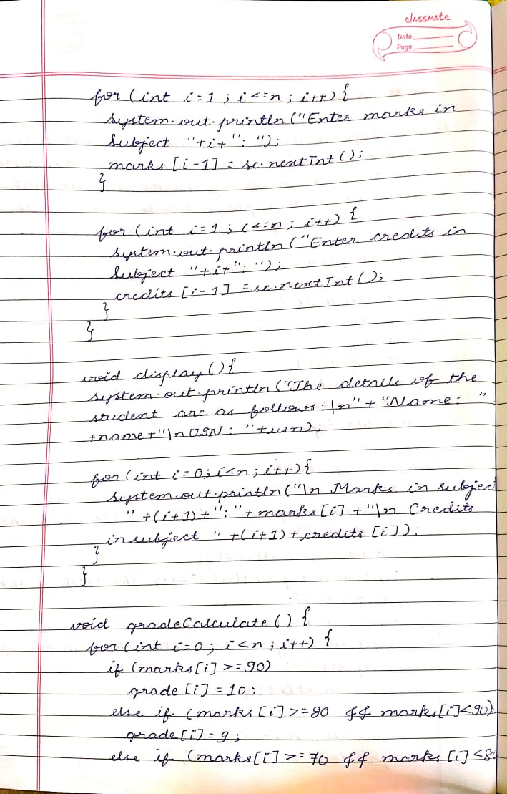

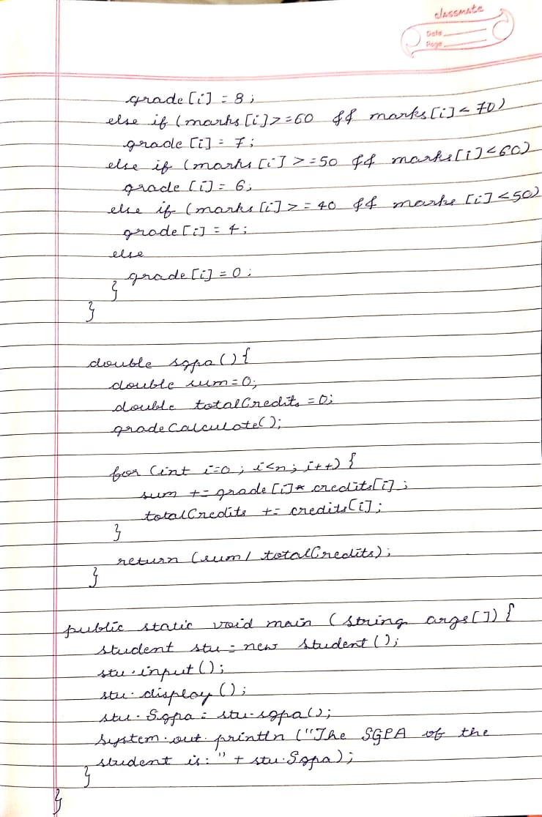

**SOURCE CODE:**

**class Student {**

**String usn,name;**

**int n;**

**int marks[];**

**int credits[];**

**int grade[];**

**double Sgpa;**

**void input() {**

**Scanner sc = new Scanner(System.in);**

**System.out.println("Enter the Name of the student:");**

**name = sc.nextLine();**

**System.out.println("Enter the USN of the student:");**

**usn = sc.nextLine();**

**System.out.println("Enter the number of subjects:");**

**n = sc.nextInt();**

**marks = new int[n];**

**credits = new int[n];**

**grade = new int[n];**

**for(int i=1;i<=n;i++){**

**System.out.println("Enter marks in Subject "+i+": ");**

**marks[i-1]=sc.nextInt();**

**}**

**for(int i=1;i<=n;i++){**

**System.out.println("Enter credits in Subject "+i+": ");**

**credits[i-1]=sc.nextInt();**

**}**

**}**

**void display(){**

**System.out.println("The details of the student are as folloows:\n"+"Name: "+name+"\nUSN: "+usn);**

**for(int i=0;i<n;i++){**

**System.out.println("\n Marks in subject "+(i+1)+":"+marks[i]+"\n Credits in subject "+(i+1)+credits[i]);**

**}**

**}**

**void gradeCalculate() {**

**for(int i=0;i<n;i++){**

**if(marks[i]>= 90)**

**grade[i]=10;**

**else if (marks[i]>=80 && marks[i]<90)**

**grade[i]=9;**

**else if (marks[i]>=70 && marks[i]<80)**

**grade[i]=8;**

**else if (marks[i]>=60 && marks[i]<70)**

**grade[i]=7;**

**else if (marks[i]>=50 && marks[i]<60)**

**grade[i]=6;**

**else if (marks[i]>=40 && marks[i]<50)**

**grade[i]=4;**

**else**

**grade[i]=0;**

**}**

**}**

**double sgpa(){**

**double sum=0;**

**double totalCredits=0;**

**gradeCalculate();**

**for(int i=0;i<n;i++){**

**sum += grade[i]*credits[i];**

**totalCredits += credits[i];**

**}**

**return (sum/totalCredits);**

**}**

**public static void main(String args[]){**

**Student stu = new Student();**

**stu.input();**

**stu.display();**

**stu.Sgpa=stu.sgpa();**

**System.out.println("The SGPA of the student is:"+stu.Sgpa);**

**}**

**}**

**OUTPUT:**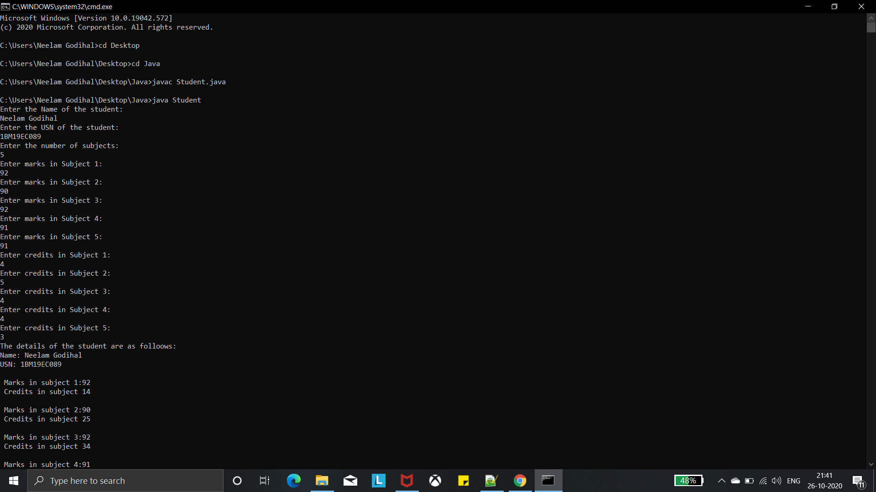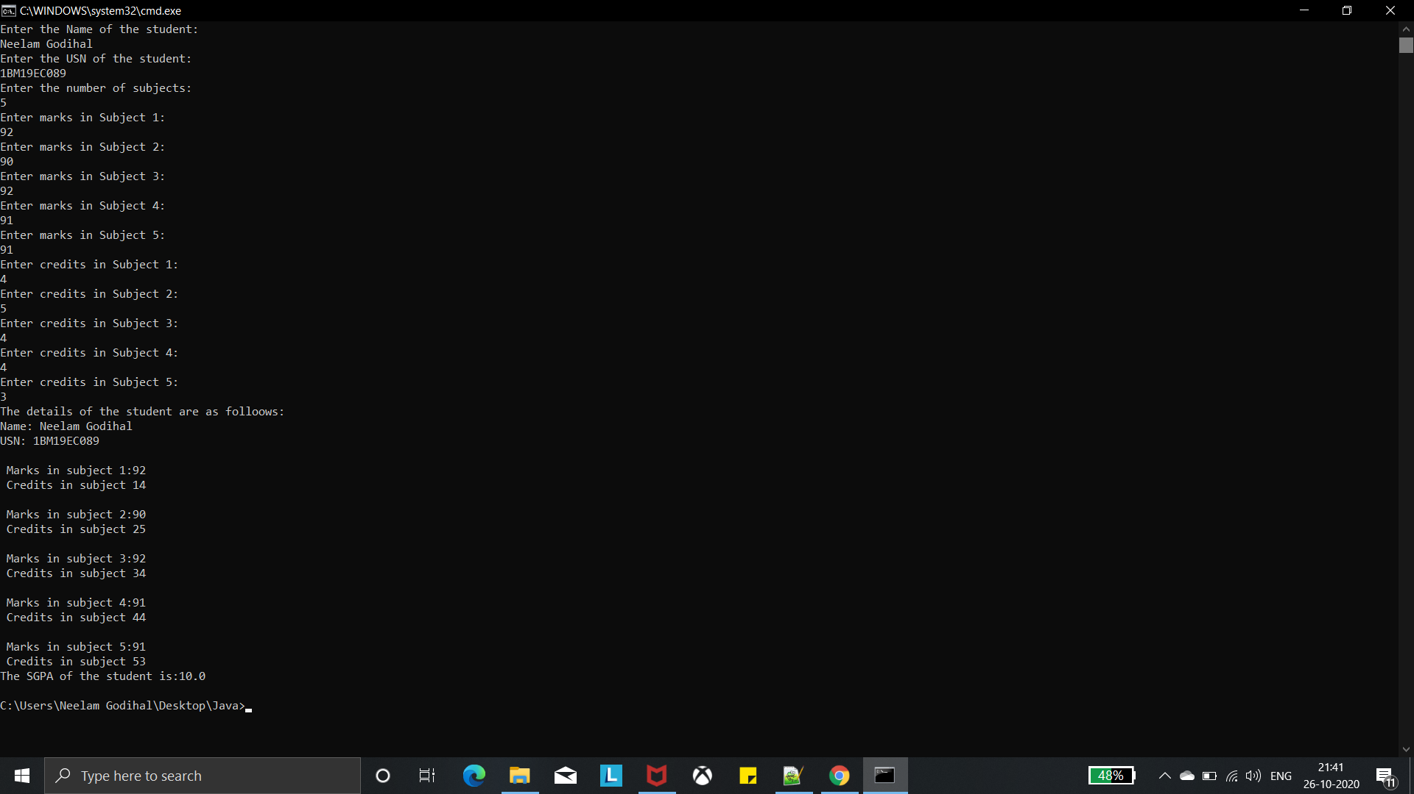

**WEEK 3:**

**WRITEUP:**

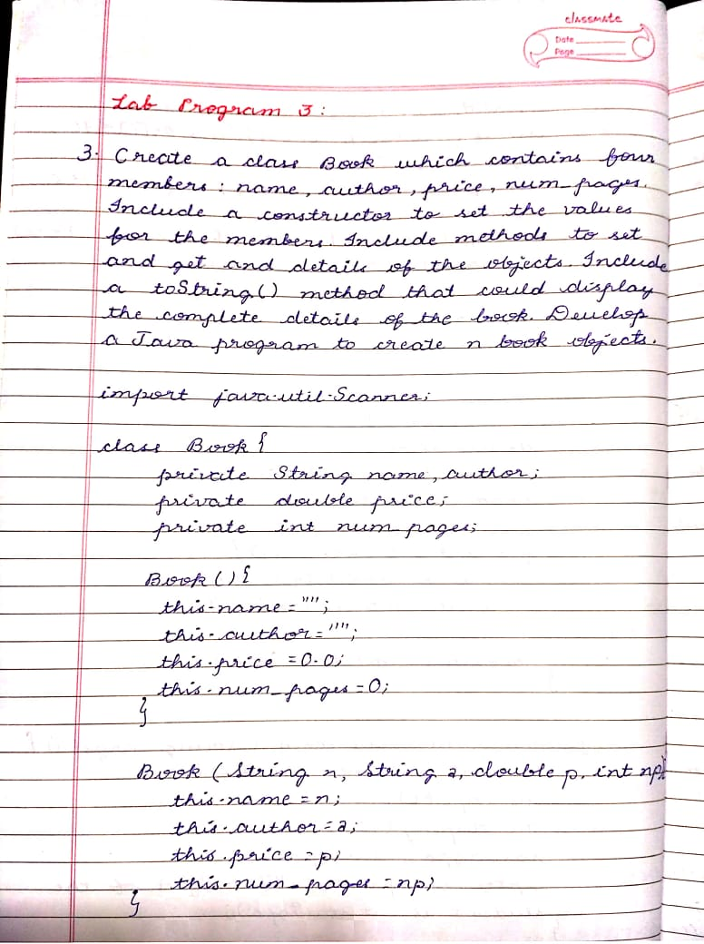

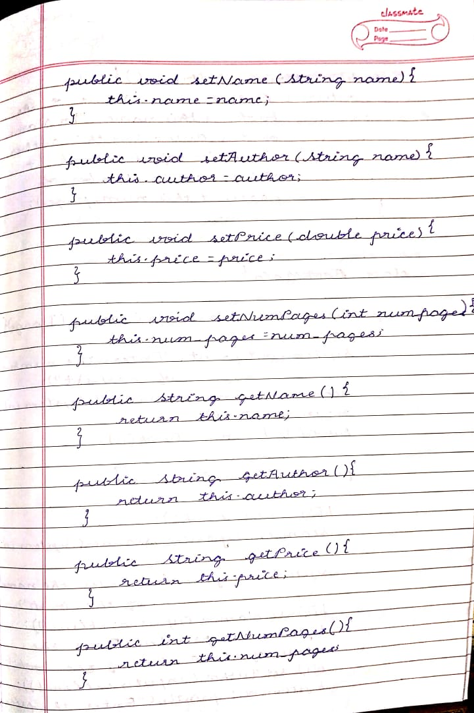

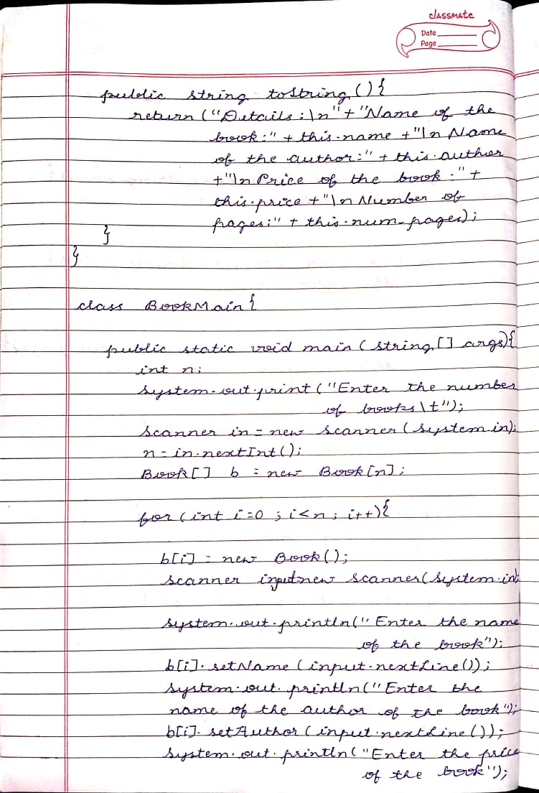

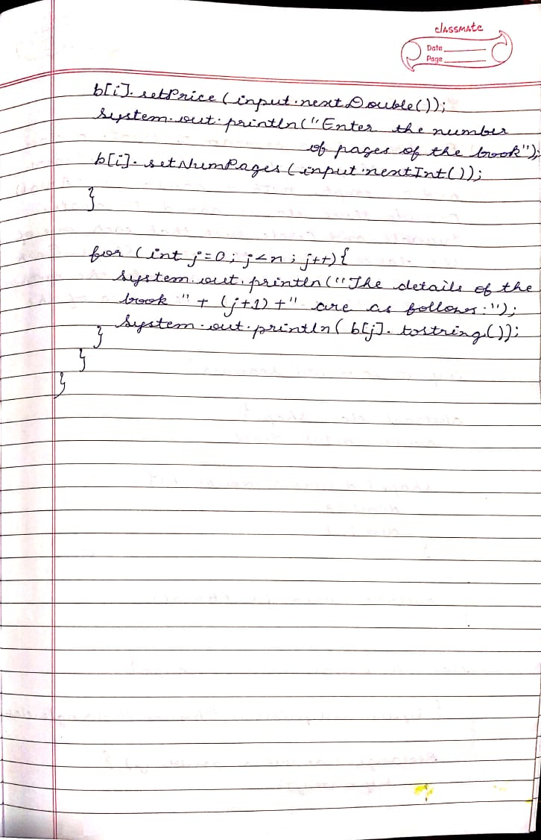

**SOURCE CODE:**

**import java.util.Scanner;**

**class Book{**

**private String name,author;**

**private double price;**

**private int num_pages;**

**Book(){**

**this.name="";**

**this.author="";**

**this.price=0.0;**

**this.num_pages=0;**

**}**

**Book(String n,String a,double p,int np){**

**this.name=n;**

**this.author=a;**

**this.price=p;**

**this.num_pages=np;**

**}**

**public void setName(String name){**

**this.name=name;**

**}**

**public void setAuthor(String author){**

**this.author=author;**

**}**

**public void setPrice(double price){**

**this.price=price;**

**}**

**public void setNumPages(int num_pages){**

**this.num_pages=num_pages;**

**}**

**public String getName(){**

**return this.name;**

**}**

**public String getAuthor(){**

**return this.author;**

**}**

**public double getPrice(){**

**return this.price;**

**}**

**public int getNumPages(){**

**return this.num_pages;**

**}**

**public String toString(){**

**return("Details:\n"+"Name of the book:"+this.name+"\nName of the author:"+this.author+"\nPrice of the book:"+this.price+"\nNumber of pages:"+this.num_pages);**

**}**

**}**

**class Main{**

**public static void main(String[] args){**

**int n;**

**System.out.print("Enter the number of books\t");**

**Scanner in = new Scanner(System.in);**

**n = in.nextInt();**

**Book[] b=new Book[n];**

**for(int i=0;i<n;i++){**

**b[i] = new Book();**

**Scanner input = new Scanner(System.in);**

**System.out.println("Enter the name of the book");**

**b[i].setName(input.nextLine());**

**System.out.println("Enter the name of the author of the book");**

**b[i].setAuthor(input.nextLine());**

**System.out.println("Enter the price of the book");**

**b[i].setPrice(input.nextDouble());**

**System.out.println("Enter the number of pages of the book");**

**b[i].setNumPages(input.nextInt());**

**}**

**for(int j=0;j<n;j++){**

**System.out.println("The details of book "+(j+1)+" are as follows:");**

**System.out.println(b[j].toString());**

**}**

**}**

**}**

**OUTPUT:**

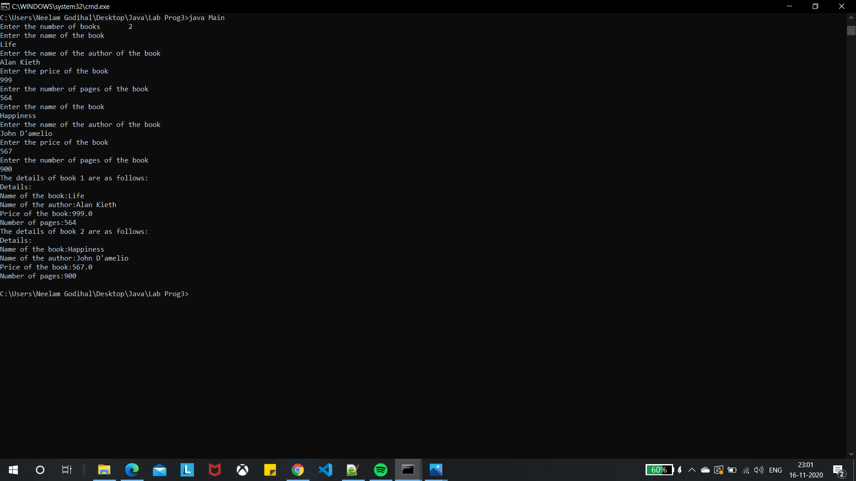

**WEEK 4:**

**WRITEUP:**

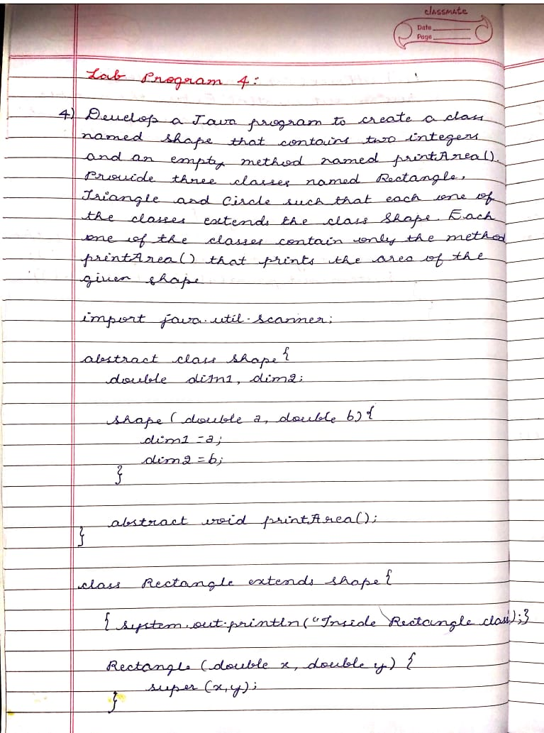

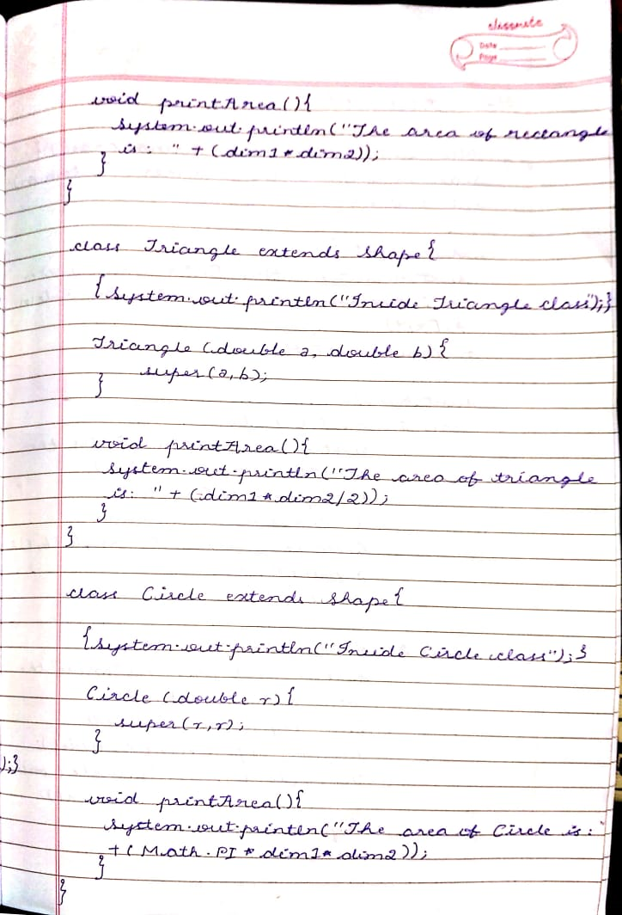

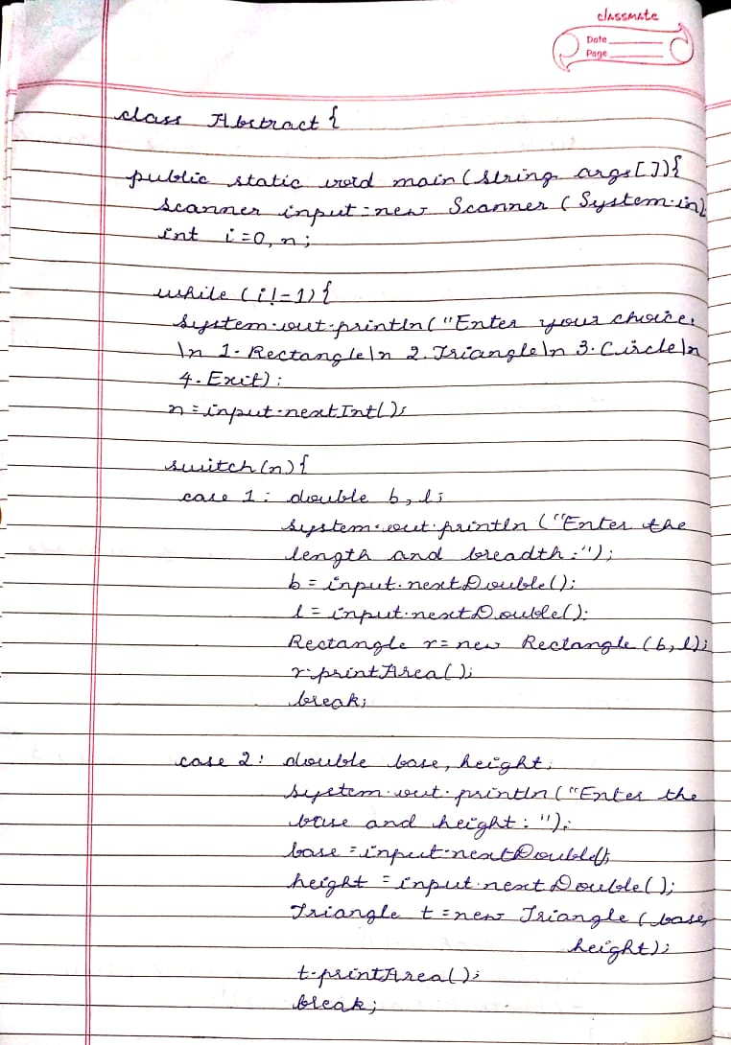

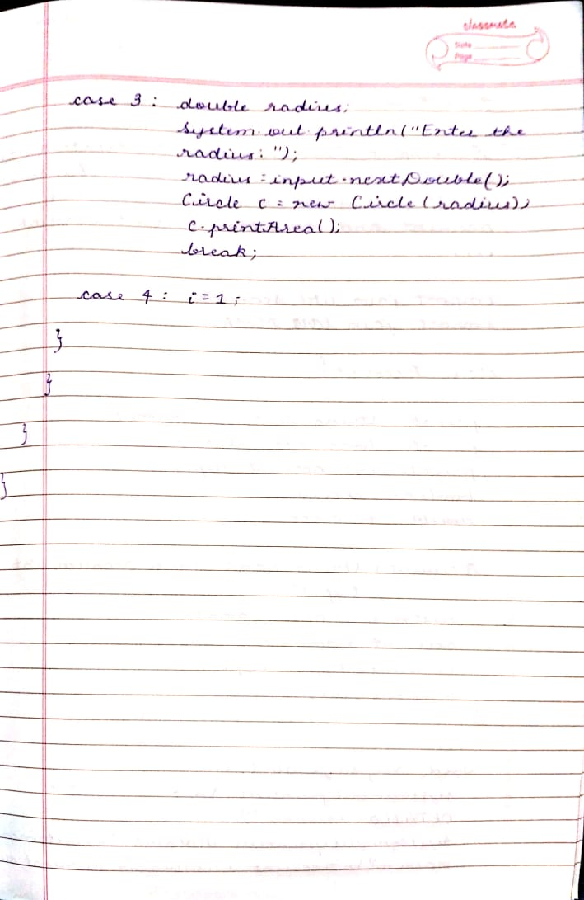

**SOURCE CODE:**

**import java.util.Scanner;**

**abstract class Shape{**

**double dim1,dim2;**

**Shape(double a,double b){**

**dim1=a;**

**dim2=b;**

**}**

**abstract void printArea();**

**}**

**class Rectangle extends Shape{**

**{System.out.println("Inside Rectangle class");}**

**Rectangle(double x,double y){**

**super(x,y);**

**}**

**void printArea(){**

**System.out.println("The area of rectangle is: "+(dim1*dim2));**

**}**

**}**

**class Triangle extends Shape{**

**{System.out.println("Inside Triangle class");}**

**Triangle(double a,double b){**

**super(a,b);**

**}**

**void printArea(){**

**System.out.println("The area of triangle is: "+(dim1*dim2/2));**

**}**

**}**

**class Circle extends Shape{**

**{System.out.println("Inside Circle class");}**

**Circle(double r){**

**super(r,r);**

**}**

**void printArea(){**

**System.out.println("The area of Circle is:"+(Math.PI*dim1*dim2));**

**}**

**}**

**class Abstract{**

**public static void main(String args[]){**

**Scanner input= new Scanner(System.in);**

**int i=0,n;**

**while(i!=1){**

**System.out.println("Enter your choice:\n 1.Rectangle\n 2.Triangle\n 3.Circle\n 4.Exit");**

**n=input.nextInt();**

**switch(n){**

**case 1: double b,l;**

**System.out.println("Enter the length and breadth:");**

**b=input.nextDouble();**

**l=input.nextDouble();**

**Rectangle r=new Rectangle(b,l);**

**r.printArea();**

**break;**

**case 2: double base,height;**

**System.out.println("Enter the base and height:");**

**base=input.nextDouble();**

**height=input.nextDouble();**

**Triangle t=new Triangle(base,height);**

**t.printArea();**

**break;**

**case 3: double radius;**

**System.out.println("Enter the radius:");**

**radius=input.nextDouble();**

**Circle c=new Circle(radius);**

**c.printArea();**

**break;**

**case 4: i=1;**

**}**

**}**

**}**

**}**

**OUTPUT:**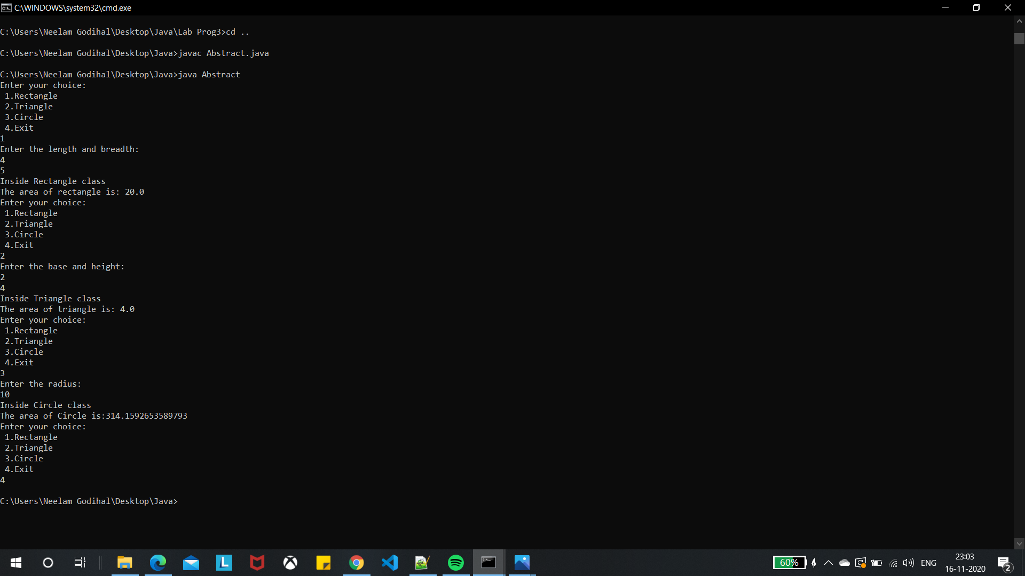

**WEEK 5:**

Develop a Java program to create a class Bank that maintains two kinds of account for its customers, one called savings account and the other current account. The savings account provides compound interest and withdrawal facilities but no cheque book facility. The current account provides cheque book facility but no interest. Current account holders should also maintain a minimum balance and if the balance falls below this level, a service charge is imposed. Create a class Account that stores customer name, account number and type of account. From this derive the classes Curr-acct and Sav-acct to make them more specific to their requirements. Include the necessary methods in order to achieve the following tasks: a) Accept deposit from customer and update the balance. a) Display the balance. b) Compute and deposit interest c) Permit withdrawal and update the balance d) Check for the minimum balance, impose penalty if necessary and update the balance

**WRITEUP:**

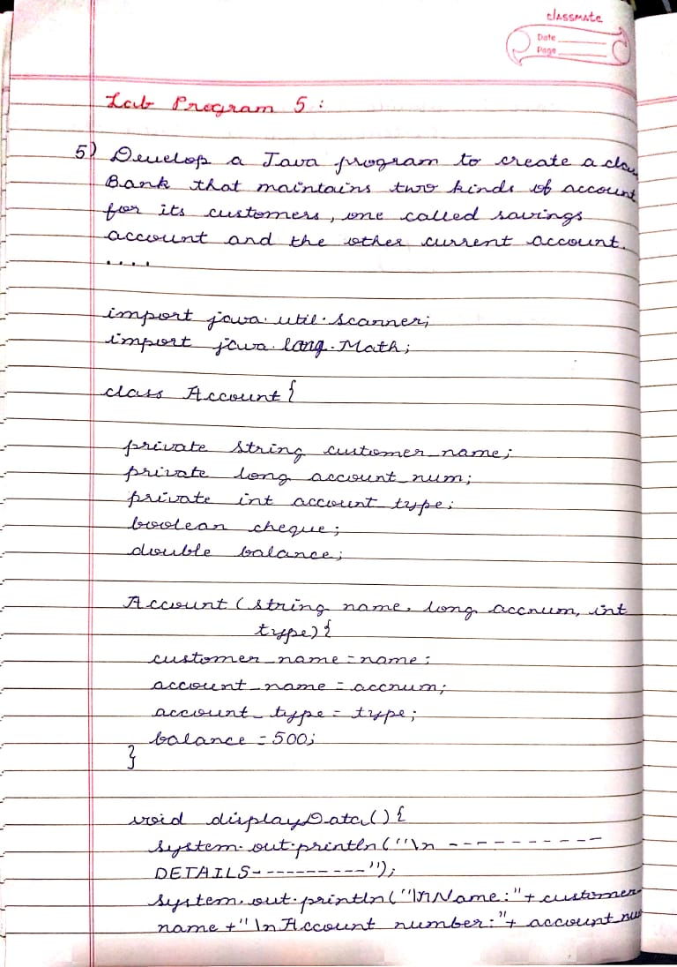

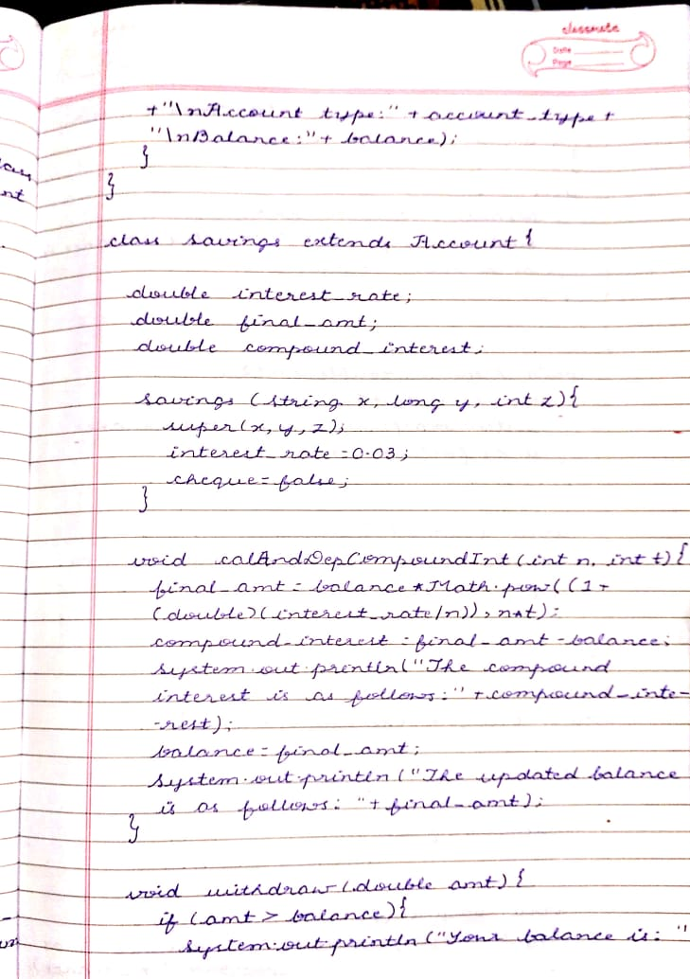

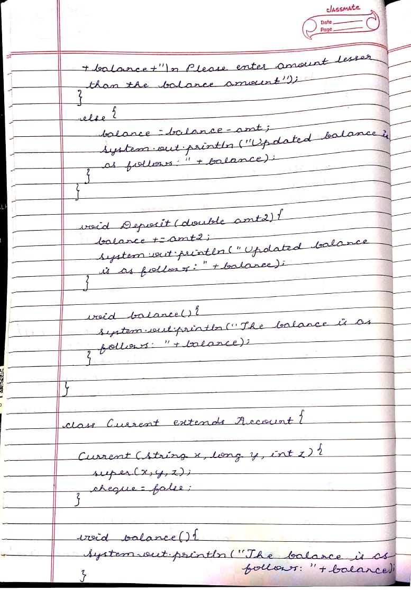

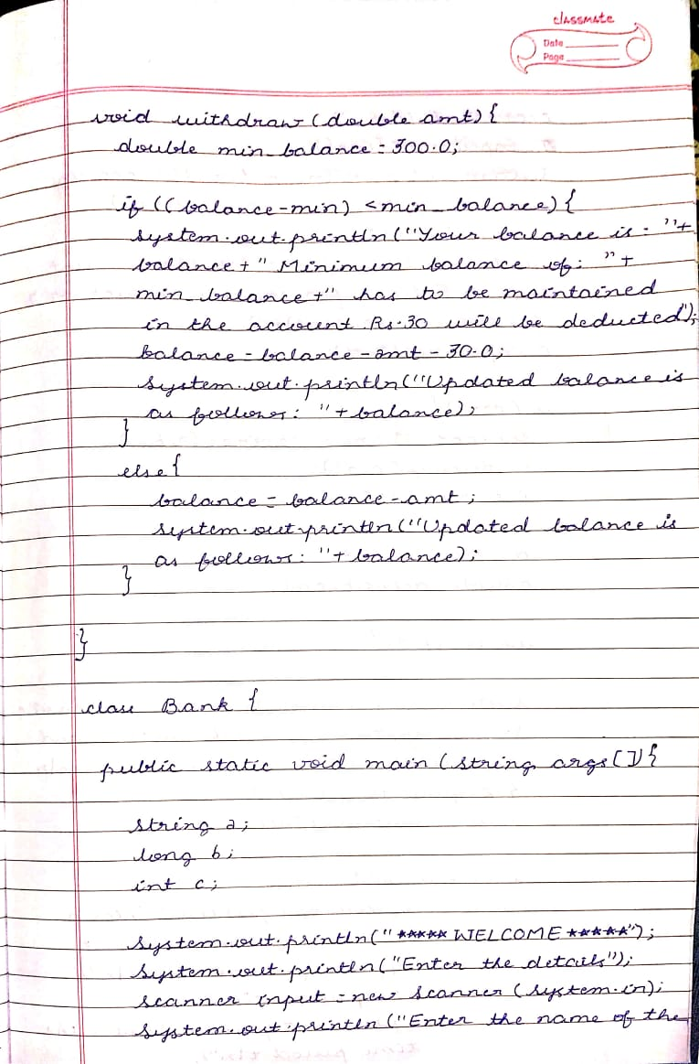

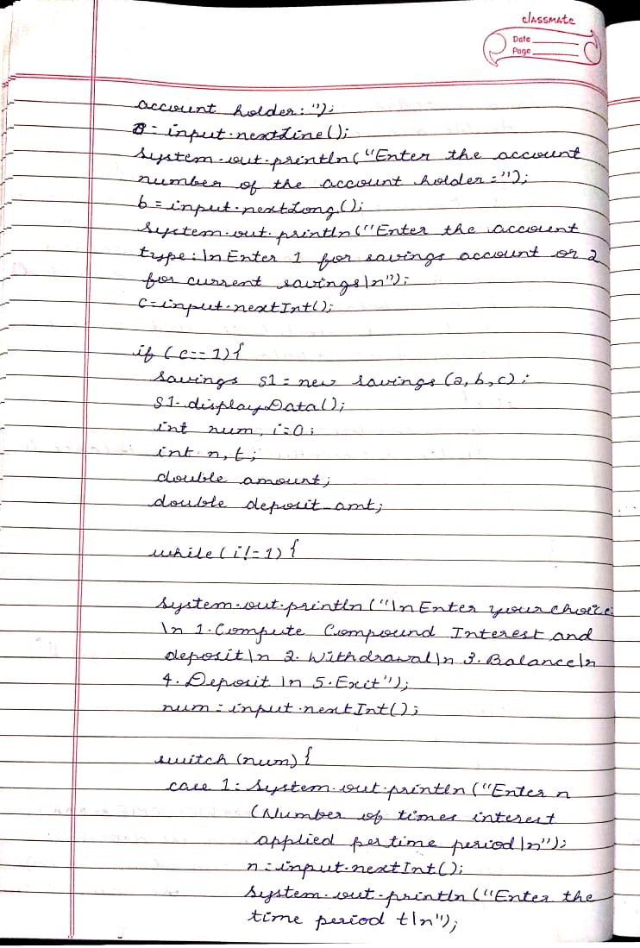

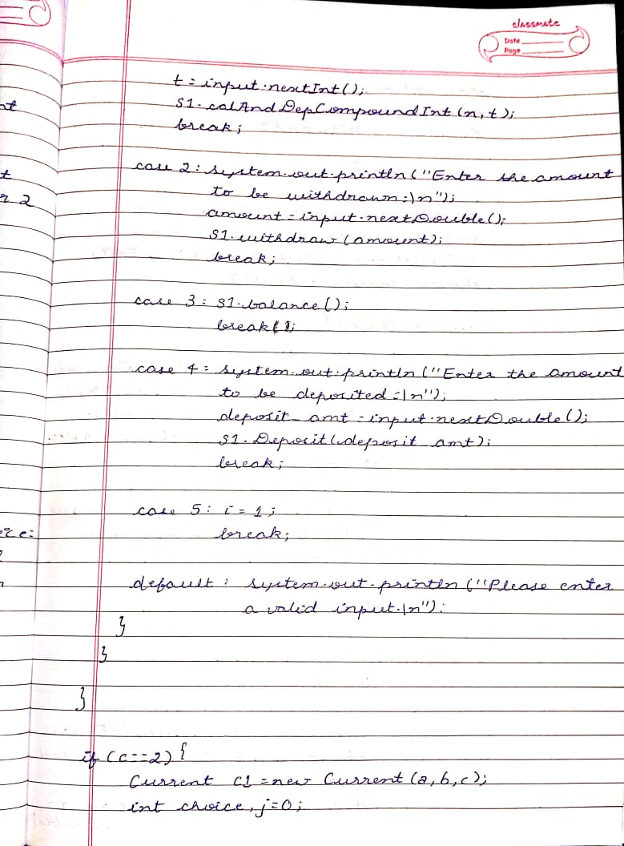

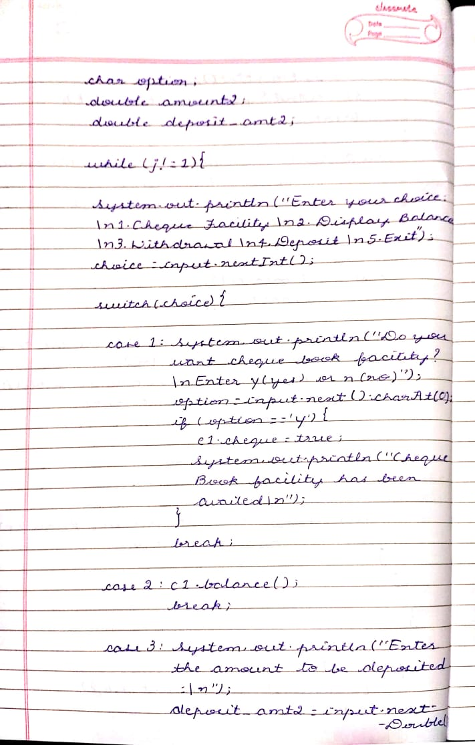

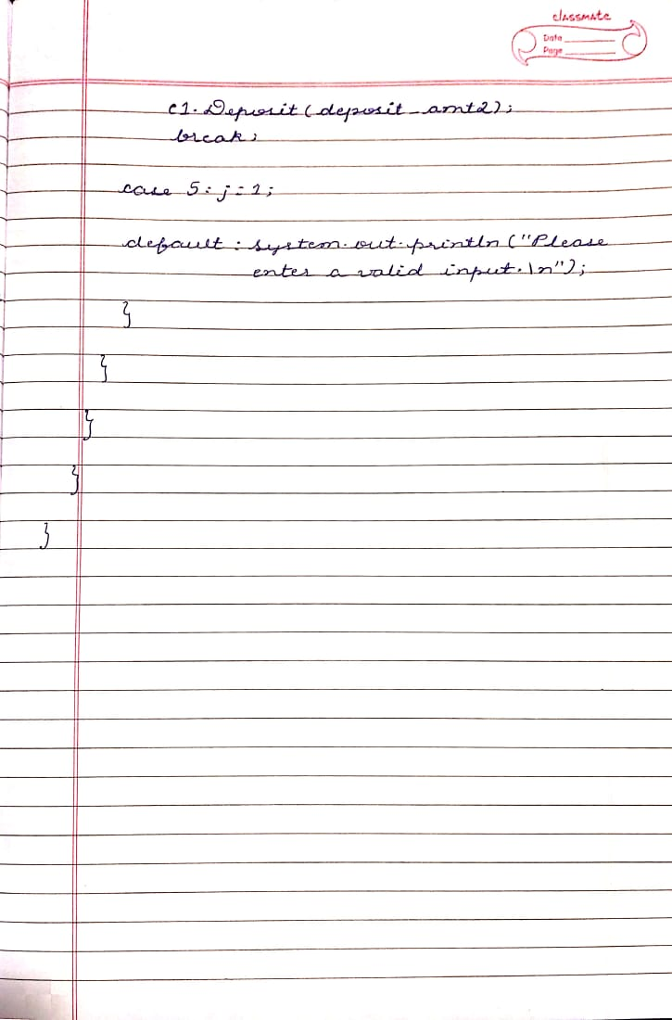

**SOURCE CODE:**

**import java.util.Scanner;**

**import java.lang.Math;**

**class Account{**

**private String customer_name;**

**private long account_num;**

**private int account_type;**

**boolean cheque;**

**double balance;**

**Account(String name,long accnum,int type){**

**customer_name=name;**

**account_num=accnum;**

**account_type=type;**

**balance=500;**

**}**

**void displayData(){**

**System.out.println("\n----------DETAILS----------");**

**System.out.println("\nName:"+customer_name+"\nAccount number:"+account_num+"\nAccount type:"+account_type+"\nBalance:"+balance);**

**}**

**}**

**class Savings extends Account{**

**double interest_rate;**

**double final_amt;**

**double compound_interest;**

**Savings(String x,long y,int z){**

**super(x,y,z);**

**interest_rate=0.03;**

**cheque=false;**

**}**

**void calAndDepCompoundInt(int n,int t){**

**final_amt=balance*Math.pow((1 + (double)(interest_rate/n)),n*t);**

**compound_interest = final_amt - balance;**

**System.out.println("The compound interest is as follows:"+compound_interest);**

**balance = final_amt;**

**System.out.println("The updated balance is as follows: "+final_amt);**

**}**

**void withdraw(double amt){**

**if(amt>balance){**

**System.out.println("Your balance is : "+balance+"\n Please enter amount lesser than the balance amount");**

**}**

**else {**

**balance=balance-amt;**

**System.out.println("Updated balance is as follows: "+balance);**

**}**

**}**

**void Deposit(double amt2){**

**balance+=amt2;**

**System.out.println("Updated balance is as follows: "+balance);**

**}**

**void balance(){**

**System.out.println("The balance is as follows: "+balance);**

**}**

**}**

**class Current extends Account{**

**Current(String x,long y,int z){**

**super(x,y,z);**

**cheque=false;**

**}**

**void balance(){**

**System.out.println("The balance is as follows: "+balance);**

**}**

**void withdraw(double amt){**

**double min_balance=300.0;**

**if((balance-amt)<min_balance){**

**System.out.println("Your balance is : "+balance+" Minimum balance of: "+min_balance+" has to be maintained in the account.Rs.30 will be deducted.");**

**balance=balance-amt-30.0;**

**System.out.println("Updated balance is as follows: "+balance);**

**}**

**else {**

**balance=balance-amt;**

**System.out.println("Updated balance is as follows: "+balance);**

**}**

**}**

**void Deposit(double amt3){**

**balance+=amt3;**

**System.out.println("Updated balance is as follows: "+balance);**

**}**

**}**

**class Bank {**

**public static void main(String args[]){**

**String a;**

**long b;**

**int c;**

**System.out.println("*****WELCOME*****");**

**System.out.println("Enter the details");**

**Scanner input=new Scanner(System.in);**

**System.out.println("Enter the name of the account holder:");**

**a=input.nextLine();**

**System.out.println("Enter the account number of the account holder:");**

**b=input.nextLong();**

**System.out.println("Enter the account type:\nEnter 1 for savings account or 2 for current savings\n");**

**c=input.nextInt();**

**if(c==1){**

**Savings s1=new Savings(a,b,c);**

**s1.displayData();**

**int num,i=0;**

**int n,t;**

**double amount;**

**double deposit_amt;**

**while(i!=1){**

**System.out.println("\nEnter your choice:\n 1.Compute Compound Interest and deposit\n 2.Withdrawal\n 3.Balance \n 4.Deposit \n 5.Exit");**

**num=input.nextInt();**

**switch(num){**

**case 1:System.out.println("Enter n(Number of times interest applied per time period)\n");**

**n=input.nextInt();**

**System.out.println("Enter the time period t\n");**

**t=input.nextInt();**

**s1.calAndDepCompoundInt(n,t);**

**break;**

**case 2:System.out.println("Enter the amount to be withdrawn:\n");**

**amount=input.nextDouble();**

**s1.withdraw(amount);**

**break;**

**case 3:s1.balance();**

**break;**

**case 4:System.out.println("Enter the amount to be deposited:\n");**

**deposit_amt=input.nextDouble();**

**s1.Deposit(deposit_amt);**

**break;**

**case 5:i=1;**

**break;**

**default: System.out.println("Please enter a valid input.\n");**

**}**

**}**

**}**

**if(c==2){**

**Current c1=new Current(a,b,c);**

**int choice,j=0;**

**char option;**

**double amount2;**

**double deposit_amt2;**

**while(j!=1){**

**System.out.println("Enter your choice:\n1.Cheque Facility \n2.Display Balance \n3.Withdrawal\n4.Deposit\n5.Exit ");**

**choice=input.nextInt();**

**switch(choice){**

**case 1: System.out.println("Do you want cheque book facility?\n Enter y(yes) or n(no)");**

**option=input.next().charAt(0);**

**if(option=='y'){**

**c1.cheque=true;**

**System.out.println("Cheque Book facility has been availed\n");**

**}**

**break;**

**case 2: c1.balance();**

**break;**

**case 3: System.out.println("Enter the amount to be withdrawn:\n");**

**amount2=input.nextDouble();**

**c1.withdraw(amount2);**

**break;**

**case 4:System.out.println("Enter the amount to be deposited:\n");**

**deposit_amt2=input.nextDouble();**

**c1.Deposit(deposit_amt2);**

**break;**

**case 5: j=1;**

**break;**

**default: System.out.println("Please enter a valid input.\n");**

**}**

**}**

**}**

**}**

**}**

**OUTPUT:**

